CSC61604 Computer Networks

Cover Page for Group Assignment

|  |  |  |  |
| --- | --- | --- | --- |
| **Team Members** | | **Student ID** | **Digital Signature** |
| Zhang Jun Yi | | 0374235 | Zhang Jun Yi |
| Chua Weng Hong | | 0366751 | Chua Weng Hong |
| Fan Lin Xiang | | 0377296 | Fan Lin Xiang |
| Chia Chen Yee | | 0380753 | Chia Chen Yee |
| Chu Yi Ming | | 0378835 | Chu Yi Ming |
|  | | | |
|  | | | |
| Name of Team Leader: Zhang JUNYI | | | |
| Tutor Name (Practical): SITI ZAINAB IBRAHIM | | | |
| Number of Pages (excluding cover page, TOC, and references): 20 | | | |
| **Keep a Copy** | Please be sure to make a copy of your work before you submit. On rare occasions an assignment gets lost in the system. In such a case, you must be able to provide another copy. | | |
| **Plagiarism** | Plagiarism is the presentation by a group of students of an assignment that has been copied in whole or in part from another group's work, or from any other source(e.g. Published  books or periodicals or internet sites) without proper  acknowledgment in the text. | | |
| **Collusion** | Collusion is the presentation by a group of students of an assignment, as their own which is in fact the result in whole or part of unauthorized collaboration with another group or groups. | | |
| **Declaration** | By submitting this assignment to Google Drive, we declare that this submission is our own work and does not involve plagiarism or collusion. | | |

**Table of Content**

[**Marking Rubric**](https://word-edit.officeapps.live.com/we/wordeditorframe.aspx?ui=zh-CN&rs=en-US&wopisrc=https%3A%2F%2Fsdtaylorsedu-my.sharepoint.com%2Fpersonal%2F0374235_sd_taylors_edu_my%2F_vti_bin%2Fwopi.ashx%2Ffiles%2Fe0d08227158143c99a96287f111dd218&wdenableroaming=1&mscc=1&wdodb=1&hid=1897E16F-916F-4B1F-B62E-B832ACC9FA98.0&uih=sharepointcom&wdlcid=zh-CN&jsapi=1&jsapiver=v2&corrid=4888358f-2acf-df39-cfd9-b57629e0bf15&usid=4888358f-2acf-df39-cfd9-b57629e0bf15&newsession=1&sftc=1&uihit=docaspx&muv=1&ats=PairwiseBroker&cac=1&sams=1&mtf=1&sfp=1&sdp=1&hch=1&hwfh=1&dchat=1&sc=%7B%22pmo%22%3A%22https%3A%2F%2Fsdtaylorsedu-my.sharepoint.com%22%2C%22pmshare%22%3Atrue%7D&ctp=LeastProtected&rct=Normal&wdorigin=AuthPrompt.Sharing.DirectLink.Copy&afdflight=36&csiro=1&instantedit=1&wopicomplete=1&wdredirectionreason=Unified_SingleFlush#_Toc215238581)

[Introduction](https://word-edit.officeapps.live.com/we/wordeditorframe.aspx?ui=zh-CN&rs=en-US&wopisrc=https%3A%2F%2Fsdtaylorsedu-my.sharepoint.com%2Fpersonal%2F0374235_sd_taylors_edu_my%2F_vti_bin%2Fwopi.ashx%2Ffiles%2Fe0d08227158143c99a96287f111dd218&wdenableroaming=1&mscc=1&wdodb=1&hid=1897E16F-916F-4B1F-B62E-B832ACC9FA98.0&uih=sharepointcom&wdlcid=zh-CN&jsapi=1&jsapiver=v2&corrid=4888358f-2acf-df39-cfd9-b57629e0bf15&usid=4888358f-2acf-df39-cfd9-b57629e0bf15&newsession=1&sftc=1&uihit=docaspx&muv=1&ats=PairwiseBroker&cac=1&sams=1&mtf=1&sfp=1&sdp=1&hch=1&hwfh=1&dchat=1&sc=%7B%22pmo%22%3A%22https%3A%2F%2Fsdtaylorsedu-my.sharepoint.com%22%2C%22pmshare%22%3Atrue%7D&ctp=LeastProtected&rct=Normal&wdorigin=AuthPrompt.Sharing.DirectLink.Copy&afdflight=36&csiro=1&instantedit=1&wopicomplete=1&wdredirectionreason=Unified_SingleFlush#_Toc215238582)

[**Part 1: Physical Space Design (Library Floor Plan with Device Placements)**](https://word-edit.officeapps.live.com/we/wordeditorframe.aspx?ui=zh-CN&rs=en-US&wopisrc=https%3A%2F%2Fsdtaylorsedu-my.sharepoint.com%2Fpersonal%2F0374235_sd_taylors_edu_my%2F_vti_bin%2Fwopi.ashx%2Ffiles%2Fe0d08227158143c99a96287f111dd218&wdenableroaming=1&mscc=1&wdodb=1&hid=1897E16F-916F-4B1F-B62E-B832ACC9FA98.0&uih=sharepointcom&wdlcid=zh-CN&jsapi=1&jsapiver=v2&corrid=4888358f-2acf-df39-cfd9-b57629e0bf15&usid=4888358f-2acf-df39-cfd9-b57629e0bf15&newsession=1&sftc=1&uihit=docaspx&muv=1&ats=PairwiseBroker&cac=1&sams=1&mtf=1&sfp=1&sdp=1&hch=1&hwfh=1&dchat=1&sc=%7B%22pmo%22%3A%22https%3A%2F%2Fsdtaylorsedu-my.sharepoint.com%22%2C%22pmshare%22%3Atrue%7D&ctp=LeastProtected&rct=Normal&wdorigin=AuthPrompt.Sharing.DirectLink.Copy&afdflight=36&csiro=1&instantedit=1&wopicomplete=1&wdredirectionreason=Unified_SingleFlush#_Toc215238583)

[*1.1 Floor Plan*](https://word-edit.officeapps.live.com/we/wordeditorframe.aspx?ui=zh-CN&rs=en-US&wopisrc=https%3A%2F%2Fsdtaylorsedu-my.sharepoint.com%2Fpersonal%2F0374235_sd_taylors_edu_my%2F_vti_bin%2Fwopi.ashx%2Ffiles%2Fe0d08227158143c99a96287f111dd218&wdenableroaming=1&mscc=1&wdodb=1&hid=1897E16F-916F-4B1F-B62E-B832ACC9FA98.0&uih=sharepointcom&wdlcid=zh-CN&jsapi=1&jsapiver=v2&corrid=4888358f-2acf-df39-cfd9-b57629e0bf15&usid=4888358f-2acf-df39-cfd9-b57629e0bf15&newsession=1&sftc=1&uihit=docaspx&muv=1&ats=PairwiseBroker&cac=1&sams=1&mtf=1&sfp=1&sdp=1&hch=1&hwfh=1&dchat=1&sc=%7B%22pmo%22%3A%22https%3A%2F%2Fsdtaylorsedu-my.sharepoint.com%22%2C%22pmshare%22%3Atrue%7D&ctp=LeastProtected&rct=Normal&wdorigin=AuthPrompt.Sharing.DirectLink.Copy&afdflight=36&csiro=1&instantedit=1&wopicomplete=1&wdredirectionreason=Unified_SingleFlush#_Toc215238584)

[*1.2 Overview and Design Feasibility*](https://word-edit.officeapps.live.com/we/wordeditorframe.aspx?ui=zh-CN&rs=en-US&wopisrc=https%3A%2F%2Fsdtaylorsedu-my.sharepoint.com%2Fpersonal%2F0374235_sd_taylors_edu_my%2F_vti_bin%2Fwopi.ashx%2Ffiles%2Fe0d08227158143c99a96287f111dd218&wdenableroaming=1&mscc=1&wdodb=1&hid=1897E16F-916F-4B1F-B62E-B832ACC9FA98.0&uih=sharepointcom&wdlcid=zh-CN&jsapi=1&jsapiver=v2&corrid=4888358f-2acf-df39-cfd9-b57629e0bf15&usid=4888358f-2acf-df39-cfd9-b57629e0bf15&newsession=1&sftc=1&uihit=docaspx&muv=1&ats=PairwiseBroker&cac=1&sams=1&mtf=1&sfp=1&sdp=1&hch=1&hwfh=1&dchat=1&sc=%7B%22pmo%22%3A%22https%3A%2F%2Fsdtaylorsedu-my.sharepoint.com%22%2C%22pmshare%22%3Atrue%7D&ctp=LeastProtected&rct=Normal&wdorigin=AuthPrompt.Sharing.DirectLink.Copy&afdflight=36&csiro=1&instantedit=1&wopicomplete=1&wdredirectionreason=Unified_SingleFlush#_Toc215238585)

[*1.3 Policies on Zoning and Connectivity*](https://word-edit.officeapps.live.com/we/wordeditorframe.aspx?ui=zh-CN&rs=en-US&wopisrc=https%3A%2F%2Fsdtaylorsedu-my.sharepoint.com%2Fpersonal%2F0374235_sd_taylors_edu_my%2F_vti_bin%2Fwopi.ashx%2Ffiles%2Fe0d08227158143c99a96287f111dd218&wdenableroaming=1&mscc=1&wdodb=1&hid=1897E16F-916F-4B1F-B62E-B832ACC9FA98.0&uih=sharepointcom&wdlcid=zh-CN&jsapi=1&jsapiver=v2&corrid=4888358f-2acf-df39-cfd9-b57629e0bf15&usid=4888358f-2acf-df39-cfd9-b57629e0bf15&newsession=1&sftc=1&uihit=docaspx&muv=1&ats=PairwiseBroker&cac=1&sams=1&mtf=1&sfp=1&sdp=1&hch=1&hwfh=1&dchat=1&sc=%7B%22pmo%22%3A%22https%3A%2F%2Fsdtaylorsedu-my.sharepoint.com%22%2C%22pmshare%22%3Atrue%7D&ctp=LeastProtected&rct=Normal&wdorigin=AuthPrompt.Sharing.DirectLink.Copy&afdflight=36&csiro=1&instantedit=1&wopicomplete=1&wdredirectionreason=Unified_SingleFlush#_Toc215238586)

[*1.4 Multi-Floor Device Placement Analysis*](https://word-edit.officeapps.live.com/we/wordeditorframe.aspx?ui=zh-CN&rs=en-US&wopisrc=https%3A%2F%2Fsdtaylorsedu-my.sharepoint.com%2Fpersonal%2F0374235_sd_taylors_edu_my%2F_vti_bin%2Fwopi.ashx%2Ffiles%2Fe0d08227158143c99a96287f111dd218&wdenableroaming=1&mscc=1&wdodb=1&hid=1897E16F-916F-4B1F-B62E-B832ACC9FA98.0&uih=sharepointcom&wdlcid=zh-CN&jsapi=1&jsapiver=v2&corrid=4888358f-2acf-df39-cfd9-b57629e0bf15&usid=4888358f-2acf-df39-cfd9-b57629e0bf15&newsession=1&sftc=1&uihit=docaspx&muv=1&ats=PairwiseBroker&cac=1&sams=1&mtf=1&sfp=1&sdp=1&hch=1&hwfh=1&dchat=1&sc=%7B%22pmo%22%3A%22https%3A%2F%2Fsdtaylorsedu-my.sharepoint.com%22%2C%22pmshare%22%3Atrue%7D&ctp=LeastProtected&rct=Normal&wdorigin=AuthPrompt.Sharing.DirectLink.Copy&afdflight=36&csiro=1&instantedit=1&wopicomplete=1&wdredirectionreason=Unified_SingleFlush#_Toc215238587)

[*1.5 Summary of Deployment Strategy*](https://word-edit.officeapps.live.com/we/wordeditorframe.aspx?ui=zh-CN&rs=en-US&wopisrc=https%3A%2F%2Fsdtaylorsedu-my.sharepoint.com%2Fpersonal%2F0374235_sd_taylors_edu_my%2F_vti_bin%2Fwopi.ashx%2Ffiles%2Fe0d08227158143c99a96287f111dd218&wdenableroaming=1&mscc=1&wdodb=1&hid=1897E16F-916F-4B1F-B62E-B832ACC9FA98.0&uih=sharepointcom&wdlcid=zh-CN&jsapi=1&jsapiver=v2&corrid=4888358f-2acf-df39-cfd9-b57629e0bf15&usid=4888358f-2acf-df39-cfd9-b57629e0bf15&newsession=1&sftc=1&uihit=docaspx&muv=1&ats=PairwiseBroker&cac=1&sams=1&mtf=1&sfp=1&sdp=1&hch=1&hwfh=1&dchat=1&sc=%7B%22pmo%22%3A%22https%3A%2F%2Fsdtaylorsedu-my.sharepoint.com%22%2C%22pmshare%22%3Atrue%7D&ctp=LeastProtected&rct=Normal&wdorigin=AuthPrompt.Sharing.DirectLink.Copy&afdflight=36&csiro=1&instantedit=1&wopicomplete=1&wdredirectionreason=Unified_SingleFlush#_Toc215238588)

[**Part 2: Network Topology Diagram and IP Addressing Scheme**](https://word-edit.officeapps.live.com/we/wordeditorframe.aspx?ui=zh-CN&rs=en-US&wopisrc=https%3A%2F%2Fsdtaylorsedu-my.sharepoint.com%2Fpersonal%2F0374235_sd_taylors_edu_my%2F_vti_bin%2Fwopi.ashx%2Ffiles%2Fe0d08227158143c99a96287f111dd218&wdenableroaming=1&mscc=1&wdodb=1&hid=1897E16F-916F-4B1F-B62E-B832ACC9FA98.0&uih=sharepointcom&wdlcid=zh-CN&jsapi=1&jsapiver=v2&corrid=4888358f-2acf-df39-cfd9-b57629e0bf15&usid=4888358f-2acf-df39-cfd9-b57629e0bf15&newsession=1&sftc=1&uihit=docaspx&muv=1&ats=PairwiseBroker&cac=1&sams=1&mtf=1&sfp=1&sdp=1&hch=1&hwfh=1&dchat=1&sc=%7B%22pmo%22%3A%22https%3A%2F%2Fsdtaylorsedu-my.sharepoint.com%22%2C%22pmshare%22%3Atrue%7D&ctp=LeastProtected&rct=Normal&wdorigin=AuthPrompt.Sharing.DirectLink.Copy&afdflight=36&csiro=1&instantedit=1&wopicomplete=1&wdredirectionreason=Unified_SingleFlush#_Toc215238589)

[*2.1 Topology Design Feasibility*](https://word-edit.officeapps.live.com/we/wordeditorframe.aspx?ui=zh-CN&rs=en-US&wopisrc=https%3A%2F%2Fsdtaylorsedu-my.sharepoint.com%2Fpersonal%2F0374235_sd_taylors_edu_my%2F_vti_bin%2Fwopi.ashx%2Ffiles%2Fe0d08227158143c99a96287f111dd218&wdenableroaming=1&mscc=1&wdodb=1&hid=1897E16F-916F-4B1F-B62E-B832ACC9FA98.0&uih=sharepointcom&wdlcid=zh-CN&jsapi=1&jsapiver=v2&corrid=4888358f-2acf-df39-cfd9-b57629e0bf15&usid=4888358f-2acf-df39-cfd9-b57629e0bf15&newsession=1&sftc=1&uihit=docaspx&muv=1&ats=PairwiseBroker&cac=1&sams=1&mtf=1&sfp=1&sdp=1&hch=1&hwfh=1&dchat=1&sc=%7B%22pmo%22%3A%22https%3A%2F%2Fsdtaylorsedu-my.sharepoint.com%22%2C%22pmshare%22%3Atrue%7D&ctp=LeastProtected&rct=Normal&wdorigin=AuthPrompt.Sharing.DirectLink.Copy&afdflight=36&csiro=1&instantedit=1&wopicomplete=1&wdredirectionreason=Unified_SingleFlush#_Toc215238590)

[*2.2 VLAN Segmentation and IP Addressing Scheme*](https://word-edit.officeapps.live.com/we/wordeditorframe.aspx?ui=zh-CN&rs=en-US&wopisrc=https%3A%2F%2Fsdtaylorsedu-my.sharepoint.com%2Fpersonal%2F0374235_sd_taylors_edu_my%2F_vti_bin%2Fwopi.ashx%2Ffiles%2Fe0d08227158143c99a96287f111dd218&wdenableroaming=1&mscc=1&wdodb=1&hid=1897E16F-916F-4B1F-B62E-B832ACC9FA98.0&uih=sharepointcom&wdlcid=zh-CN&jsapi=1&jsapiver=v2&corrid=4888358f-2acf-df39-cfd9-b57629e0bf15&usid=4888358f-2acf-df39-cfd9-b57629e0bf15&newsession=1&sftc=1&uihit=docaspx&muv=1&ats=PairwiseBroker&cac=1&sams=1&mtf=1&sfp=1&sdp=1&hch=1&hwfh=1&dchat=1&sc=%7B%22pmo%22%3A%22https%3A%2F%2Fsdtaylorsedu-my.sharepoint.com%22%2C%22pmshare%22%3Atrue%7D&ctp=LeastProtected&rct=Normal&wdorigin=AuthPrompt.Sharing.DirectLink.Copy&afdflight=36&csiro=1&instantedit=1&wopicomplete=1&wdredirectionreason=Unified_SingleFlush#_Toc215238591)

[**Part 3: Configuration Details**](https://word-edit.officeapps.live.com/we/wordeditorframe.aspx?ui=zh-CN&rs=en-US&wopisrc=https%3A%2F%2Fsdtaylorsedu-my.sharepoint.com%2Fpersonal%2F0374235_sd_taylors_edu_my%2F_vti_bin%2Fwopi.ashx%2Ffiles%2Fe0d08227158143c99a96287f111dd218&wdenableroaming=1&mscc=1&wdodb=1&hid=1897E16F-916F-4B1F-B62E-B832ACC9FA98.0&uih=sharepointcom&wdlcid=zh-CN&jsapi=1&jsapiver=v2&corrid=4888358f-2acf-df39-cfd9-b57629e0bf15&usid=4888358f-2acf-df39-cfd9-b57629e0bf15&newsession=1&sftc=1&uihit=docaspx&muv=1&ats=PairwiseBroker&cac=1&sams=1&mtf=1&sfp=1&sdp=1&hch=1&hwfh=1&dchat=1&sc=%7B%22pmo%22%3A%22https%3A%2F%2Fsdtaylorsedu-my.sharepoint.com%22%2C%22pmshare%22%3Atrue%7D&ctp=LeastProtected&rct=Normal&wdorigin=AuthPrompt.Sharing.DirectLink.Copy&afdflight=36&csiro=1&instantedit=1&wopicomplete=1&wdredirectionreason=Unified_SingleFlush#_Toc215238592)

[*3.1 Core Router Configuration (VLAN Interconnections and External Connections)*](https://word-edit.officeapps.live.com/we/wordeditorframe.aspx?ui=zh-CN&rs=en-US&wopisrc=https%3A%2F%2Fsdtaylorsedu-my.sharepoint.com%2Fpersonal%2F0374235_sd_taylors_edu_my%2F_vti_bin%2Fwopi.ashx%2Ffiles%2Fe0d08227158143c99a96287f111dd218&wdenableroaming=1&mscc=1&wdodb=1&hid=1897E16F-916F-4B1F-B62E-B832ACC9FA98.0&uih=sharepointcom&wdlcid=zh-CN&jsapi=1&jsapiver=v2&corrid=4888358f-2acf-df39-cfd9-b57629e0bf15&usid=4888358f-2acf-df39-cfd9-b57629e0bf15&newsession=1&sftc=1&uihit=docaspx&muv=1&ats=PairwiseBroker&cac=1&sams=1&mtf=1&sfp=1&sdp=1&hch=1&hwfh=1&dchat=1&sc=%7B%22pmo%22%3A%22https%3A%2F%2Fsdtaylorsedu-my.sharepoint.com%22%2C%22pmshare%22%3Atrue%7D&ctp=LeastProtected&rct=Normal&wdorigin=AuthPrompt.Sharing.DirectLink.Copy&afdflight=36&csiro=1&instantedit=1&wopicomplete=1&wdredirectionreason=Unified_SingleFlush#_Toc215238593)

[*3.2 Access Control and Security Implementation*](https://word-edit.officeapps.live.com/we/wordeditorframe.aspx?ui=zh-CN&rs=en-US&wopisrc=https%3A%2F%2Fsdtaylorsedu-my.sharepoint.com%2Fpersonal%2F0374235_sd_taylors_edu_my%2F_vti_bin%2Fwopi.ashx%2Ffiles%2Fe0d08227158143c99a96287f111dd218&wdenableroaming=1&mscc=1&wdodb=1&hid=1897E16F-916F-4B1F-B62E-B832ACC9FA98.0&uih=sharepointcom&wdlcid=zh-CN&jsapi=1&jsapiver=v2&corrid=4888358f-2acf-df39-cfd9-b57629e0bf15&usid=4888358f-2acf-df39-cfd9-b57629e0bf15&newsession=1&sftc=1&uihit=docaspx&muv=1&ats=PairwiseBroker&cac=1&sams=1&mtf=1&sfp=1&sdp=1&hch=1&hwfh=1&dchat=1&sc=%7B%22pmo%22%3A%22https%3A%2F%2Fsdtaylorsedu-my.sharepoint.com%22%2C%22pmshare%22%3Atrue%7D&ctp=LeastProtected&rct=Normal&wdorigin=AuthPrompt.Sharing.DirectLink.Copy&afdflight=36&csiro=1&instantedit=1&wopicomplete=1&wdredirectionreason=Unified_SingleFlush#_Toc215238594)

[*3.3 Switch Configuration*](https://word-edit.officeapps.live.com/we/wordeditorframe.aspx?ui=zh-CN&rs=en-US&wopisrc=https%3A%2F%2Fsdtaylorsedu-my.sharepoint.com%2Fpersonal%2F0374235_sd_taylors_edu_my%2F_vti_bin%2Fwopi.ashx%2Ffiles%2Fe0d08227158143c99a96287f111dd218&wdenableroaming=1&mscc=1&wdodb=1&hid=1897E16F-916F-4B1F-B62E-B832ACC9FA98.0&uih=sharepointcom&wdlcid=zh-CN&jsapi=1&jsapiver=v2&corrid=4888358f-2acf-df39-cfd9-b57629e0bf15&usid=4888358f-2acf-df39-cfd9-b57629e0bf15&newsession=1&sftc=1&uihit=docaspx&muv=1&ats=PairwiseBroker&cac=1&sams=1&mtf=1&sfp=1&sdp=1&hch=1&hwfh=1&dchat=1&sc=%7B%22pmo%22%3A%22https%3A%2F%2Fsdtaylorsedu-my.sharepoint.com%22%2C%22pmshare%22%3Atrue%7D&ctp=LeastProtected&rct=Normal&wdorigin=AuthPrompt.Sharing.DirectLink.Copy&afdflight=36&csiro=1&instantedit=1&wopicomplete=1&wdredirectionreason=Unified_SingleFlush#_Toc215238595)

[**Part 4: Troubleshooting Documentation**](https://word-edit.officeapps.live.com/we/wordeditorframe.aspx?ui=zh-CN&rs=en-US&wopisrc=https%3A%2F%2Fsdtaylorsedu-my.sharepoint.com%2Fpersonal%2F0374235_sd_taylors_edu_my%2F_vti_bin%2Fwopi.ashx%2Ffiles%2Fe0d08227158143c99a96287f111dd218&wdenableroaming=1&mscc=1&wdodb=1&hid=1897E16F-916F-4B1F-B62E-B832ACC9FA98.0&uih=sharepointcom&wdlcid=zh-CN&jsapi=1&jsapiver=v2&corrid=4888358f-2acf-df39-cfd9-b57629e0bf15&usid=4888358f-2acf-df39-cfd9-b57629e0bf15&newsession=1&sftc=1&uihit=docaspx&muv=1&ats=PairwiseBroker&cac=1&sams=1&mtf=1&sfp=1&sdp=1&hch=1&hwfh=1&dchat=1&sc=%7B%22pmo%22%3A%22https%3A%2F%2Fsdtaylorsedu-my.sharepoint.com%22%2C%22pmshare%22%3Atrue%7D&ctp=LeastProtected&rct=Normal&wdorigin=AuthPrompt.Sharing.DirectLink.Copy&afdflight=36&csiro=1&instantedit=1&wopicomplete=1&wdredirectionreason=Unified_SingleFlush#_Toc215238596)

[*4.1 Connectivity Verification Results*](https://word-edit.officeapps.live.com/we/wordeditorframe.aspx?ui=zh-CN&rs=en-US&wopisrc=https%3A%2F%2Fsdtaylorsedu-my.sharepoint.com%2Fpersonal%2F0374235_sd_taylors_edu_my%2F_vti_bin%2Fwopi.ashx%2Ffiles%2Fe0d08227158143c99a96287f111dd218&wdenableroaming=1&mscc=1&wdodb=1&hid=1897E16F-916F-4B1F-B62E-B832ACC9FA98.0&uih=sharepointcom&wdlcid=zh-CN&jsapi=1&jsapiver=v2&corrid=4888358f-2acf-df39-cfd9-b57629e0bf15&usid=4888358f-2acf-df39-cfd9-b57629e0bf15&newsession=1&sftc=1&uihit=docaspx&muv=1&ats=PairwiseBroker&cac=1&sams=1&mtf=1&sfp=1&sdp=1&hch=1&hwfh=1&dchat=1&sc=%7B%22pmo%22%3A%22https%3A%2F%2Fsdtaylorsedu-my.sharepoint.com%22%2C%22pmshare%22%3Atrue%7D&ctp=LeastProtected&rct=Normal&wdorigin=AuthPrompt.Sharing.DirectLink.Copy&afdflight=36&csiro=1&instantedit=1&wopicomplete=1&wdredirectionreason=Unified_SingleFlush#_Toc215238597)

[*4.2 Critical Troubleshooting Logs*](https://word-edit.officeapps.live.com/we/wordeditorframe.aspx?ui=zh-CN&rs=en-US&wopisrc=https%3A%2F%2Fsdtaylorsedu-my.sharepoint.com%2Fpersonal%2F0374235_sd_taylors_edu_my%2F_vti_bin%2Fwopi.ashx%2Ffiles%2Fe0d08227158143c99a96287f111dd218&wdenableroaming=1&mscc=1&wdodb=1&hid=1897E16F-916F-4B1F-B62E-B832ACC9FA98.0&uih=sharepointcom&wdlcid=zh-CN&jsapi=1&jsapiver=v2&corrid=4888358f-2acf-df39-cfd9-b57629e0bf15&usid=4888358f-2acf-df39-cfd9-b57629e0bf15&newsession=1&sftc=1&uihit=docaspx&muv=1&ats=PairwiseBroker&cac=1&sams=1&mtf=1&sfp=1&sdp=1&hch=1&hwfh=1&dchat=1&sc=%7B%22pmo%22%3A%22https%3A%2F%2Fsdtaylorsedu-my.sharepoint.com%22%2C%22pmshare%22%3Atrue%7D&ctp=LeastProtected&rct=Normal&wdorigin=AuthPrompt.Sharing.DirectLink.Copy&afdflight=36&csiro=1&instantedit=1&wopicomplete=1&wdredirectionreason=Unified_SingleFlush#_Toc215238598)

[References](https://word-edit.officeapps.live.com/we/wordeditorframe.aspx?ui=zh-CN&rs=en-US&wopisrc=https%3A%2F%2Fsdtaylorsedu-my.sharepoint.com%2Fpersonal%2F0374235_sd_taylors_edu_my%2F_vti_bin%2Fwopi.ashx%2Ffiles%2Fe0d08227158143c99a96287f111dd218&wdenableroaming=1&mscc=1&wdodb=1&hid=1897E16F-916F-4B1F-B62E-B832ACC9FA98.0&uih=sharepointcom&wdlcid=zh-CN&jsapi=1&jsapiver=v2&corrid=4888358f-2acf-df39-cfd9-b57629e0bf15&usid=4888358f-2acf-df39-cfd9-b57629e0bf15&newsession=1&sftc=1&uihit=docaspx&muv=1&ats=PairwiseBroker&cac=1&sams=1&mtf=1&sfp=1&sdp=1&hch=1&hwfh=1&dchat=1&sc=%7B%22pmo%22%3A%22https%3A%2F%2Fsdtaylorsedu-my.sharepoint.com%22%2C%22pmshare%22%3Atrue%7D&ctp=LeastProtected&rct=Normal&wdorigin=AuthPrompt.Sharing.DirectLink.Copy&afdflight=36&csiro=1&instantedit=1&wopicomplete=1&wdredirectionreason=Unified_SingleFlush#_Toc215238599)

[Appendix](https://word-edit.officeapps.live.com/we/wordeditorframe.aspx?ui=zh-CN&rs=en-US&wopisrc=https%3A%2F%2Fsdtaylorsedu-my.sharepoint.com%2Fpersonal%2F0374235_sd_taylors_edu_my%2F_vti_bin%2Fwopi.ashx%2Ffiles%2Fe0d08227158143c99a96287f111dd218&wdenableroaming=1&mscc=1&wdodb=1&hid=1897E16F-916F-4B1F-B62E-B832ACC9FA98.0&uih=sharepointcom&wdlcid=zh-CN&jsapi=1&jsapiver=v2&corrid=4888358f-2acf-df39-cfd9-b57629e0bf15&usid=4888358f-2acf-df39-cfd9-b57629e0bf15&newsession=1&sftc=1&uihit=docaspx&muv=1&ats=PairwiseBroker&cac=1&sams=1&mtf=1&sfp=1&sdp=1&hch=1&hwfh=1&dchat=1&sc=%7B%22pmo%22%3A%22https%3A%2F%2Fsdtaylorsedu-my.sharepoint.com%22%2C%22pmshare%22%3Atrue%7D&ctp=LeastProtected&rct=Normal&wdorigin=AuthPrompt.Sharing.DirectLink.Copy&afdflight=36&csiro=1&instantedit=1&wopicomplete=1&wdredirectionreason=Unified_SingleFlush#_Toc215238600)

[*IP Address of Kiosk & E-payment(Default Gateway 192.168.40.1)*](https://word-edit.officeapps.live.com/we/wordeditorframe.aspx?ui=zh-CN&rs=en-US&wopisrc=https%3A%2F%2Fsdtaylorsedu-my.sharepoint.com%2Fpersonal%2F0374235_sd_taylors_edu_my%2F_vti_bin%2Fwopi.ashx%2Ffiles%2Fe0d08227158143c99a96287f111dd218&wdenableroaming=1&mscc=1&wdodb=1&hid=1897E16F-916F-4B1F-B62E-B832ACC9FA98.0&uih=sharepointcom&wdlcid=zh-CN&jsapi=1&jsapiver=v2&corrid=4888358f-2acf-df39-cfd9-b57629e0bf15&usid=4888358f-2acf-df39-cfd9-b57629e0bf15&newsession=1&sftc=1&uihit=docaspx&muv=1&ats=PairwiseBroker&cac=1&sams=1&mtf=1&sfp=1&sdp=1&hch=1&hwfh=1&dchat=1&sc=%7B%22pmo%22%3A%22https%3A%2F%2Fsdtaylorsedu-my.sharepoint.com%22%2C%22pmshare%22%3Atrue%7D&ctp=LeastProtected&rct=Normal&wdorigin=AuthPrompt.Sharing.DirectLink.Copy&afdflight=36&csiro=1&instantedit=1&wopicomplete=1&wdredirectionreason=Unified_SingleFlush#_Toc215238601)

[*IP Address of the 2 printer*](https://word-edit.officeapps.live.com/we/wordeditorframe.aspx?ui=zh-CN&rs=en-US&wopisrc=https%3A%2F%2Fsdtaylorsedu-my.sharepoint.com%2Fpersonal%2F0374235_sd_taylors_edu_my%2F_vti_bin%2Fwopi.ashx%2Ffiles%2Fe0d08227158143c99a96287f111dd218&wdenableroaming=1&mscc=1&wdodb=1&hid=1897E16F-916F-4B1F-B62E-B832ACC9FA98.0&uih=sharepointcom&wdlcid=zh-CN&jsapi=1&jsapiver=v2&corrid=4888358f-2acf-df39-cfd9-b57629e0bf15&usid=4888358f-2acf-df39-cfd9-b57629e0bf15&newsession=1&sftc=1&uihit=docaspx&muv=1&ats=PairwiseBroker&cac=1&sams=1&mtf=1&sfp=1&sdp=1&hch=1&hwfh=1&dchat=1&sc=%7B%22pmo%22%3A%22https%3A%2F%2Fsdtaylorsedu-my.sharepoint.com%22%2C%22pmshare%22%3Atrue%7D&ctp=LeastProtected&rct=Normal&wdorigin=AuthPrompt.Sharing.DirectLink.Copy&afdflight=36&csiro=1&instantedit=1&wopicomplete=1&wdredirectionreason=Unified_SingleFlush#_Toc215238602)

[*IoT Device IP Address Mapping*](https://word-edit.officeapps.live.com/we/wordeditorframe.aspx?ui=zh-CN&rs=en-US&wopisrc=https%3A%2F%2Fsdtaylorsedu-my.sharepoint.com%2Fpersonal%2F0374235_sd_taylors_edu_my%2F_vti_bin%2Fwopi.ashx%2Ffiles%2Fe0d08227158143c99a96287f111dd218&wdenableroaming=1&mscc=1&wdodb=1&hid=1897E16F-916F-4B1F-B62E-B832ACC9FA98.0&uih=sharepointcom&wdlcid=zh-CN&jsapi=1&jsapiver=v2&corrid=4888358f-2acf-df39-cfd9-b57629e0bf15&usid=4888358f-2acf-df39-cfd9-b57629e0bf15&newsession=1&sftc=1&uihit=docaspx&muv=1&ats=PairwiseBroker&cac=1&sams=1&mtf=1&sfp=1&sdp=1&hch=1&hwfh=1&dchat=1&sc=%7B%22pmo%22%3A%22https%3A%2F%2Fsdtaylorsedu-my.sharepoint.com%22%2C%22pmshare%22%3Atrue%7D&ctp=LeastProtected&rct=Normal&wdorigin=AuthPrompt.Sharing.DirectLink.Copy&afdflight=36&csiro=1&instantedit=1&wopicomplete=1&wdredirectionreason=Unified_SingleFlush#_Toc215238603)

### **Marking Rubric**

**Assessment Rubric: Cisco Badges (6%)**

|  |  |  |  |  |
| --- | --- | --- | --- | --- |
| **Criteria** | **Completed**  **(1)** | **Not Completed**  **(0)** | **Weightage** | **Obtained Marks** |
| Badges 1: Getting started with Cisco Packet Tracer |  |  | 2% |  |
| Badges 2: Exploring Networking with Cisco Packet Tracer |  |  | 2% |  |
| Badges 3: Exploring Internet of Things with Cisco Packet Tracer |  |  | 2% |  |
| **Total** |  | | |  |

**Assessment Rubric: Peer Evaluation (4%)**

|  |  |  |  |  |  |
| --- | --- | --- | --- | --- | --- |
| **Criteria** | **Full**  **(4)** | **Partial**  **(2-3)** | **Minimal**  **(1)** | **None**  **(0)** | **Obtained Marks** |
| Contribution to team | Consistently contributed meaningfully to all project tasks and took initiative in group discussions and execution. | Contributed to several tasks but with varying consistency or depth. Some initiative shown. | Rarely contributed or only completed basic assigned tasks with limited involvement. | Did not contribute to the group work in any meaningful way. |  |
| Communication and collaboration | Communicated effectively and respectfully. Actively supported collaboration and problem-solving within the team. | Communicated adequately but may have been passive or occasionally unresponsive. Collaborated when prompted. | Communication was infrequent, unclear, or not constructive. Limited interaction with team. | No communication or engagement with the group throughout the project. |  |
| Timeliness and reliability | Always met deadlines and was dependable in completing assigned tasks without reminders. | Mostly dependable; occasionally needed prompting or extensions but still delivered results. | Often submitted tasks late or inconsistently; others had to compensate. | Did not complete assigned work or meet any deadlines. Unreliable. |  |
| **Totals** |  | | | | |

**Assessment Criteria: Report and CPT File (15%)**

|  |  |  |  |  |  |
| --- | --- | --- | --- | --- | --- |
| **Criteria** | **Excellent**  **(9-10)** | **Good**  **(7-8)** | **Satisfactory**  **(5-6)** | **Poor**  **(0-4)** | **Obtained Marks** |
| Completeness and organization of content | All required sections are present, well-organized, and logically structured. Content flows clearly from introduction to conclusion with strong coherence. | Most sections are complete and organized logically, with minor lapses in flow or structure. Some content could be better integrated. | Some required sections are missing or poorly structured. Content may appear fragmented or lack clear transitions. | Many sections are missing or disorganized. Report lacks coherence and logical progression. |  |
| **Feasibility of physical layout and floor plan** | Proposal is practical, cost-effective, and addresses identified issues. Justification are well-supported by technical reasoning | Proposal is generally feasible with minor oversights. Reasonable justification is provided. | Proposal is simplistic or only partially feasible. Some justification is present but lacks technical depth. | Proposal is unrealistic, incomplete, or lacks justification. No link to actual findings. |  |
| Feasibility of network design proposal | Proposal is practical, cost- effective, and addresses identified issues. Justifications are well-supported by technical reasoning. | Proposal is generally feasible with minor oversights. Reasonable justification is provided. | Proposal is simplistic or only partially feasible. Some justification is present but lacks technical depth. | Proposal is unrealistic, incomplete, or lacks justification. No link to actual findings. |  |
| **Configuration of network devices** | All network devices are correctly configured, including DHCP, static IPs for external servers, wireless setting, and default gateways. All configuration function as intended with no errors | Most configuration are correct; minor issues may exist(e.g., missed DNS entry or subnet mask). Connectivity mostly functional. | Serval Configuration are incomplete or incorrect (e.g. missing DHCP scopes or router interface misconfigured), but core devices still communicate | Serval Configuration are incomplete or incorrect (e.g. missing DHCP scopes or router interface misconfigured), but core devices still communicate |  |
| Connectivity verification | All connectivity tests completed successfully: all device types (PCs, tablets, POS, IP cams, smart sensor) can communicate with the correct internal and external endpoints. | Most connectivity checks successful; a few failed pings or incomplete DHCP leases but main functionalities verified. | Some connectivity verifications incomplete; some devices cannot reach targets (e.g., POS not reaching PaySys or IP cams unreachable). | Many devices fail to obtain IP or cannot reach test targets. Basic connectivity exists for a limited set of devices. |  |
| Writing quality and formatting | Language is clear, concise, and free of grammatical errors. Formatting is consistent and professional. | Minor language issues or formatting inconsistencies. Overall readability is good. | Some grammar or clarity issues. Formatting may be inconsistent or unpolished. | Numerous grammar and formatting errors. Difficult to read or unprofessional appearance. |  |
| **Total** |  | | | | |

**Assessment Rubric (Presentation – 5%)**

|  |  |  |  |  |  |
| --- | --- | --- | --- | --- | --- |
| **Criteria** | **Excellent**  **(5)** | **Good**  **(4)** | **Satisfactory**  **(3)** | **Poor**  **(0-2)** | **Obtained Marks** |
| Clear explanation of findings and proposal | Presentation clearly explains the community findings and proposed network solution with strong technical accuracy and coherence. Ideas are communicated logically and effectively. | Findings and proposal are mostly well explained with good clarity. Minor gaps in technical detail or flow. | Basic explanation is provided but lacks depth, clarity, or logical flow. Some key points are unclear or underdeveloped. | Explanation is vague, confusing, or lacks coherence. Findings and proposal are poorly communicated or incomplete. |  |
| Engagement and time management | Presentation is engaging, well- paced, and within the allocated time. Presenters maintain attention and interest. | Generally engaging and mostly well-timed, with only minor lapses in pacing or delivery. | Presentation is somewhat engaging but may exceed or fall short of time limits. Limited audience connection. | Presentation is rushed or too long. Lacks engagement or attention to audience dynamics. |  |
| Use of visuals and voice clarity | Visual aids (slides, diagrams) are clear, well-designed, and support key points. Voice is clear and confident throughout. | Visuals are appropriate and voice is mostly clear. Minor issues in delivery or slide clarity. | Visuals are present but may lack clarity or relevance. Voice may be unclear or inconsistent. | Visuals are missing or ineffective. Voice delivery is unclear, monotone, or difficult to understand. |  |
| **Demonstration** | **Successful (1)** | | **Partially Successful (0.5)** | **Unsuccessful (0)** |  |
| Staff PCs → University Library Server & Internet |  |  |  |  |  |
| Student devices → Internet & digital catalog only |  |  |  |  |  |
| Kiosks → University Library Server |  |  |  |  |  |
| E-payment Terminals → Payment Gateway Server |  |  |  |  |  |
| IP Cameras & IoT Sensors → Admin PC in staff office |  |  |  |  |  |
| **Total** |  | | | | |

|  |  |
| --- | --- |
| **Team Members** | **Student ID** |
| Zhang Jun Yi | 0374235 |
| Chua Weng Hong | 0366751 |
| Fan Lin Xiang | 0377296 |
| Chia Chen Yee | 0380753 |
| Chu Yi Ming | 0378835 |

# Introduction

This report is about the design and configure a LAN topology by applying networking principles for both wired and wireless environment and integrating IoT and external connectivity. We have also designed a Physical Layout, which is the Floor Plan of Taylor’s University Library. The title of this assignment is to design a Smart Library System by using Cisco Packet Tracer. We must upgrade the network infrastructure to let different kind of user such as Staff, Student to have a smooth network experience, and ensure efficient library services, and smart IoT device management.

In this report, our solution will cover 20 wired Staff PC, 100 wireless Student Device that can access to the network and University digital resources, 2 network printers that can accessible via the Staff network. 10 self-service kiosks with RFID book scanners for book borrowing/returns that connect to University Library Server, and 3 wired e-payment terminals for fines and fees. 10 IP Security Camera placed at entrances, pods and reading halls, and various of IoT device that place in the study zone. For external connectivity, there are 2 server that provide service to the library, which is University Library Server that provide Digital catalog and resource synchronization, and Payment Gateway Server that provide secure payment transaction.

The tools to design Physical Floor Plan in this report is MODAO and CAD. We use Cisco Packet Tracer to design our Logical Design of the Network and check the connectivity between the devices **(M, 2022)**.

# Part 1: Physical Space Design (Library Floor Plan with Device Placements)

1.1 Floor Plan

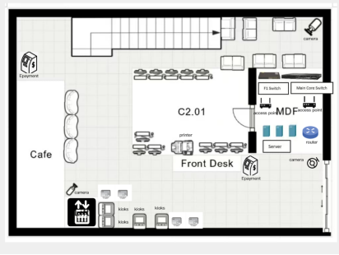

Figure 1 Floor Plan of the Ground Floor

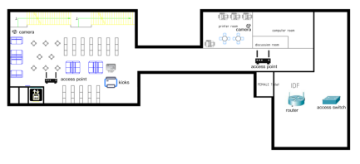

Figure 2 Floor Plan of the First Floor

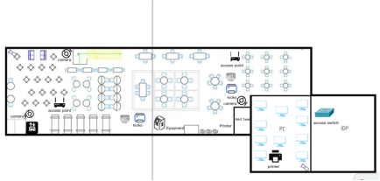

Figure 3 Floor Plan of the Second Floor

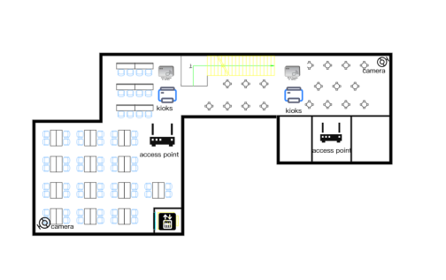

Figure 4 Floor Plan of the Third Plan

1.2 Overview and Design Feasibility

The following diagram illustrates the physical layout of the library floors (also interpretable as a bird's-eye view) and provides detailed scientific justification for the deployment locations of all network and security equipment. Our team's design philosophy consistently adheres to core principles: ensuring Wi-Fi coverage throughout the entire library, optimizing cabling routes to reduce costs, and clearly delineating wired and wireless zones. Based on our group discussions, this solution effectively guarantees both the technical reliability and security of the equipment.

1.3 Policies on Zoning and Connectivity

Implement strict zoning to ensure service stability in critical areas and enhance the user experience for student devices. Below, I will detail the scope and functions of the two zones.

Wired Zones: Based on our assessment, wired zones require high bandwidth and primarily serve critical devices or applications, including but not limited to faculty computer offices, self-service kiosks, service counter areas, and printer locations. Within the library network, all self-service kiosks and electronic payment terminals will utilize wired connections to effectively guarantee transaction security and provide corresponding convenience for students.

Wireless Zones: Primarily encompass the main reading hall, group study areas, and student seating self-study zones. Due to high student mobility in these areas, access points (APs) will be deployed to ensure device portability and mobility.

1.4 Multi-Floor Device Placement Analysis

i) Ground Floor / Main Lobby

|  |  |  |
| --- | --- | --- |
| Device | Placement Location | Technical Justification |
| MDF / Core Equipment (Router, Core Switch, Server) | Located in a dedicated secure equipment room near the front desk. | Installing the main distribution frame here can significantly reduce the amount of trunk cabling required for external lines and centralize server security management. |
| Access Points (APs) | Located near the front desk and entrance. | Effectively ensures users gain immediate Wi-Fi coverage upon entering the library and supports high-density traffic near the front desk. |
| Kiosks & E-payment | Placed at the Front Desk | Wired connections ensure reliable Provide services to users, thereby ensuring the security of services and the stability of transactions. |
| Cameras | Placed at corners and entrance points. | Monitor high-traffic areas and critical assets. |

ii) First Floor / Main Study Hall

|  |  |  |
| --- | --- | --- |
| Device | Placement Location | Technical Justification |
| Access Points (APs) | Within the library, two wireless access points are located in the spacious study hall: one in the central area and another near the seating section on the left. | The library has implemented comprehensive Wi-Fi coverage to ensure effective wireless connectivity within designated student study areas. |
| Access Switch / IDP | Located adjacent to the Staff PC Office. | The equipment will centrally manage wired connections for employee computers, self-service terminals, and printers on this floor to facilitate efficient administration. |
| Kiosks | Placed centrally within the study hall near the dividing line. | Placed in high-traffic student areas to ensure self-service kiosks are easily accessible and convenient for users. |
| Cameras | Placed at corners and above the general study area. | Monitor both entrances and the general seating area for students. |

iii) Second Floor / Quiet Study & IT

|  |  |  |
| --- | --- | --- |
| Device | Placement Location | Technical Justification |
| IDF (Access Switch) | Located in a secure closet/room. | The library utilizes floor-level patch panels. An intermediate distribution frame (IDF) is established to manage connections specific to that floor and route them back to the main distribution frame (MDF), thereby optimizing internal cabling within the floor. |
| Access Points (APs) | One AP covers the discussion room and one covers the main quiet study area. | Ensure that group discussion collaboration spaces and quiet reading areas have dedicated wireless services. |
| Printers | Located in a dedicated printer room adjacent to the computer room. | Provide printing resources for students using the computer lab. |
| Kiosks | Placed near the bookshelves. | Located near the resource area for convenient self-service borrowing, enhancing user accessibility. |
| E-payment | Place at the middle of Second Floor | No much people is at there so student can make transaction securely. |

iv) Third Floor / Group Study

|  |  |  |
| --- | --- | --- |
| Device | Placement Location | Technical Justification |
| Access Points (APs) | Two APs are distributed between the main group study clusters. | Ensure sufficient wireless bandwidth is available within student group discussion areas and for multimedia applications. |
| Kiosks | Placed near the entrance and within the study clusters. | Provide convenient, quick self-service stations for students participating in group activities. |
| Cameras | Placed at a corner and monitoring the main seating clusters. | Surveillance cameras have been installed in high-traffic group discussion areas. |

1.5 Summary of Deployment Strategy

The multi-layer design successfully achieves comprehensive coverage and security objectives, with the following specific functions:

**Comprehensive Wi-Fi Coverage:**

Access points (APs) are meticulously deployed on every floor, with targeted coverage specifically designed for high-traffic areas to ensure seamless wireless connectivity for users.

**Comprehensive Security Coverage:**

Surveillance cameras are deployed at key entrances and exits on all floors, in high-value asset areas, and along primary pathways, significantly ensuring the security of user assets and the library's overall safety and reliability.

**Wired coverage and reliability:**

Critical services (servers, self-service terminals, electronic payments) and employee functions are centrally deployed in secure locations. With the support of wired connections, this approach further ensures system stability and service continuity.

# Part 2: Network Topology Diagram and IP Addressing Scheme

**2.1 Topology Design Feasibility**

Our team's network design employs a Hierarchical Logical Design to ensure scalability while facilitating administrator oversight. The core zone features a single router connected to other systems via “sticks” for efficient data transmission, eliminating frequent three-layer switching. Access layer switches then connect all endpoints, ensuring each layer receives an appropriate number of ports. This hierarchical approach aligns with industry best practices for building scalable and reliable networks **(Cisco, 2023 )** This solution separates services from clients using VLANs, creating distinct tiers for improved management and service delivery.

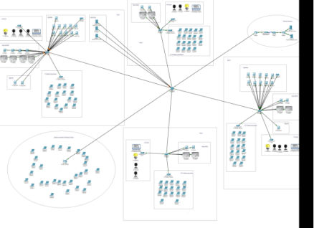

Figure 5 Overall look of the Smart Library System

Our design is to assign different kind of network by using switch, so we use main core switch to connect the switches of all floors, and also connect to the router that can connect to the external router to access the services of the external server.

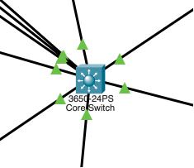

Figure 6 Main core switch

So, we divide our design into 6 segments, which is F1, F2, F3, F4, External Connectivity and Wireless router Wi-Fi connection.

First Floor

For first floor, we use a Switch to connect the 10 staff PCs, 1 Admin PC to manage the IoT devices, 1 Printers that connect to the Staff VLAN, 3 servers that place in the MDF which is IoT server and DHCP server of Staff and Student to assign IP address to staff and student. 1 Access point that connect the IoT device of the First Floor, 4 Kiosk with RFID reader for book borrow and return, 2 E-Payment Gateway to make transaction, and a access point that for student to connect the WI-FI smoothly.

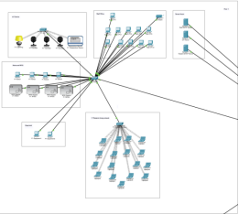

Figure 7 F1 Logical Plan For Floor 1

Second Floor

For second Floor, we don’t have any Staff PC and E-payment gateway, we only include 2 kiosks with RFID reader for book borrow and return, 1 access point for student to connect the wifi, and 1 more access point for IoT devices connection.

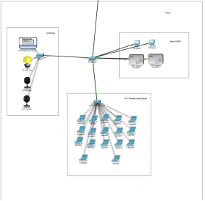

Figure 8 Logical Plan for Second Floor

And also we have included a Wireless router and place it at floor 2 for All floor of Student can connect the network smoothly.

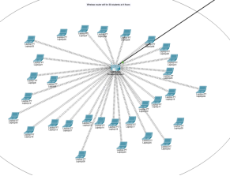

Figure 9 Wireless Router for student to connect

Third Floor

For third floor, we have a switch that connect 10 Staff PCs and 1 printer that connect to the Staff VLAN, and then we connect switches with 2 Kiosks with the RFID Reader, 1 E-payment, 1 Access point for student to connect the WIFI and 1 access point to connect the IoT devices.

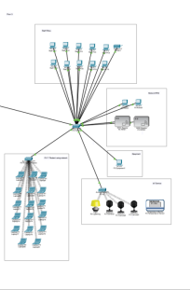

Figure 10 Logical Plan for Third Floor

Fourth Floor

For Fourth Floor, we got 2 Kiosk with 2 RFID Reader, 1 Access point for student to connect the Wi-Fi, and 1 more access point for the IoT devices connection.

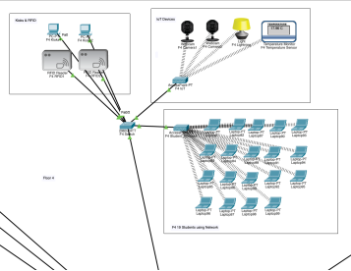

Figure 11 Logical Plan for Fourth Floor

External Connectivity

We have internet access to University Library Server and Payment Gateway Server for book borrow/return and transaction making.

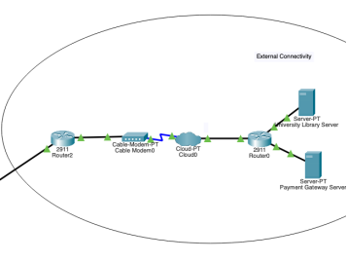

Figure 12 External Connectivity

**2.2 VLAN Segmentation and IP Addressing Scheme**

To meet allocation requirements (faculty/staff, students, IoT devices, library services), our team established four primary VLANs to ensure manageability, isolation, and security. Effective network segmentation reduces broadcast domains and enhances security by isolating sensitive traffic **(Stallings, 2013).**

|  |  |  |  |  |
| --- | --- | --- | --- | --- |
| VLAN | Role | Network Segment | Addressing Method | Justification |
| 10 | Staff | 192.168.10.0/24 | DHCP / Static | Support employee computers and printers. Provide administrators with static IP addresses. |
| 20 | Student | 192.168.20.0/24 | DHCP | Provides dynamic addressing for up to 100 simultaneous Wi-Fi users21. |
| 30 | IoT Devices | 192.168.30.0/24 | Static | Isolate IP camera 23 and sensor 24 for monitoring and management via the administrator PC. |
| 40 | Library Service | 192.168.40.0/24 | Static | Ensure effective connectivity between self-service terminals and electronic payment terminals. |

# Part 3: Configuration Details

**3.1 Core Router Configuration (VLAN Interconnections and External Connections)**

**Inter-VLAN Routing & Default Gateways:** The router creates sub interfaces for each VLAN, configuring the Dot1Q encapsulation protocol and corresponding default gateway IP addresses. This approach provides services to all internal networks.

**DHCP Implementation:** DHCP service is configured on the router to perform dynamic allocation within VLAN 10 and VLAN 20. This configuration eliminates the need for any static IP address mappings at the root level.

**Routing Protocol:** Utilizes the RIP protocol for dynamic network routing management to enable secure access to external servers.

**Network Address Translation (NAT):** Our network is configured with NAT overloading functionality, enabling all internal VLANs to share a single public IP address. This conservation of public IP addresses is a key benefit of Port Address Translation (PAT) in enterprise environments (Lammle, 2016). This facilitates more secure access to the Internet and external server terminals.

The configuration details for each are as follows:

**Inter-VLAN Routing：**

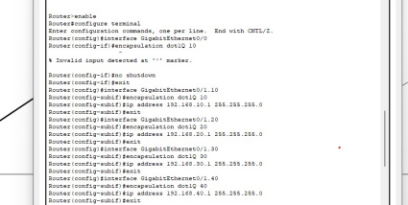

**Cross-VLAN Routing (Router Cascading Solution):**

By configuring router subinterfaces (e.g., G0/1.10 to .40), segmenting traffic using Dot1Q encapsulation technology, and assigning default gateways to each VLAN, efficient cross-VLAN routing is achieved.

DHCP Service:

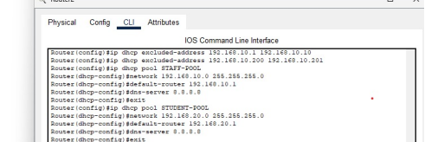

**DHCP Service Implementation:**

Separate DHCP address pools have been defined for the faculty subnet (VLAN 10) and the student subnet (VLAN 20). Critical static IP addresses (e.g., printers located at .200/.201) are excluded from the dynamic allocation range to prevent address conflicts.

**NAT Configuration：**

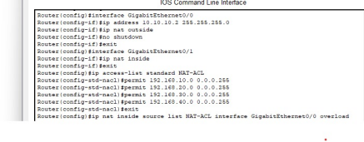

**NAT (PAT) Configuration:**

The external interface (G0/0) is labeled as `ip nat outside`, while the internal interface (G0/1) is labeled as `ip nat inside`. By applying NAT Overload (PAT) technology through the NAT Access Control List (NAT-ACL), all internal VLAN traffic is translated, enabling internal devices to share a public IP address for secure internet access.

**RIP Protocol**

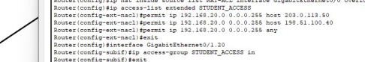

**RIPv2 Routing Protocol:**

RIP version 2 is configured to advertise all internal subnets (192.168.x.x) and the external network (10.0.0.0). This dynamic routing protocol ensures that all network segments can efficiently learn and maintain routes for proper inter-VLAN and external connectivity.

**3.2 Access Control and Security Implementation**

**Access Control Lists (ACLs):** ACLs are deployed on the library's routers to meet specific management requirements. These ACLs restrict traffic from the student VLAN (VLAN 20) to allow access only to the Internet and the digital catalog (here based on the university library server: 203.0.113.50). All requests to access other internal VLANs—such as staff, IoT, services, etc.—are intercepted by an implicit “deny all” rule.

**Static IP Mapping:** Based on our observations, all servers, self-service terminals, electronic payment terminals, and IoT devices within the library are configured with static IP addresses to ensure enhanced security and stability of services.

The configuration details for each are as follows:

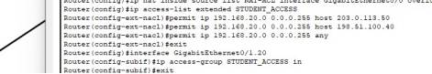

**STUDENT_ACCESS Access Control List Implementation:**

The extended access control list STUDENT_ACCESS explicitly permits VLAN 20 traffic to access only the library server (203.0.113.50), payment gateway (198.51.100.40), and the Internet (any address). This access control list is applied to inbound traffic on the G0/0/1.20 subinterface to enforce strict security isolation, blocking all requests from other internal VLANs.

**3.3 Switch Configuration**

VLAN Implementation: All required VLANs have been created on the switches, such as VLANs 10, 20, 30, and 40. Ports on the core switches and access points connecting to the library network are configured as trunk ports, while ports connecting to end devices are configured as access ports. These ports assign VLANs accordingly. The configuration details for each are as follows:

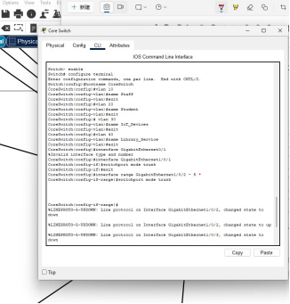

Core Switch

**Core Switch Trunk Configuration:**

All required VLANs (10, 20, 30, 40) have been created. Uplink interfaces (GigabitEthernet1/0/1 to the router and GigabitEthernet1/0/2-5 to the access switches) are configured with switchport mode trunk to carry traffic for all segmented networks.

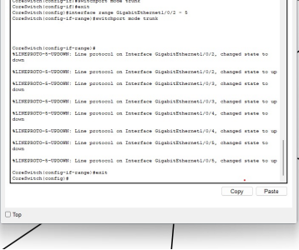

F1 Access Switch

(The configuration of the F1 Access Switch is used as the primary example for port assignment and VLAN segmentation. The F2, F3, and F4 Access Switches follow the identical configuration structure, adapting only the access port assignment based on their respective floor plans and device zoning requirements.)

F1 Access Port Assignment Example:

The F1 switch configuration confirms the assignment of end-device ports: F0/5-14 are assigned to VLAN 10 (Staff); F0/15-20 to VLAN 40 (Service); and dedicated ports are assigned to VLAN 30 (IoT) and VLAN 20 (Student AP). This validates the implementation of strict zoning policies at the access layer.

# Part 4: Troubleshooting Documentation

In Part 4, we documented the entire server verification process to ensure all connectivity tests could run securely and meet standards. Failure logs were also recorded.

**4.1 Connectivity Verification Results**

Our tests employed the Ping method. The following results are the detection outcomes:

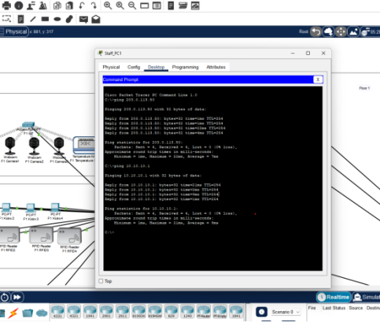

**Test Target:** Staff PCs → Library Server / Staff PCs → External

**Connectivity Requirement:** Must communicate with server / Must communicate with Internet

**Actual Result：** Ping 203.0.113.50 Reply / Ping 10.10.10.1 Reply

**Status：** Success

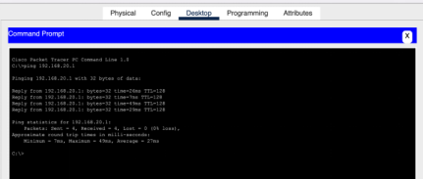

**Test Target:** Student devices → Digital Catalog

**Connectivity Requirement：**Must communicate with digital catalog only

**Actual Result：** Ping 192.168.20.1 Reply

**Status：** Success

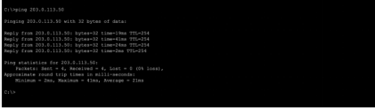

**Test Target:** Kiosks → University Library Server

**Connectivity Requirement：**Must communicate with server

**Actual Result：** Ping 203.0.113.50 Reply

**Status：** Success

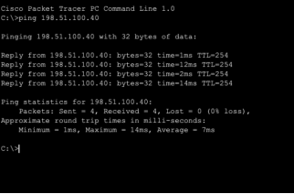

**Test Target:** E-payment Terminals → Payment Gateway

**Connectivity Requirement：**Must communicate with external server

**Actual Result：** Ping 198.51.100.40 Reply

**Status：** Success

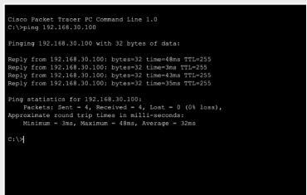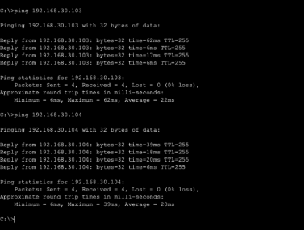

**Test Target：**IP Cameras/IoT → Admin PC

**Connectivity Requirement：**Must communicate with Admin PC

**Actual Result：**Ping 192.168.30.200 Reply

**Status：**Success

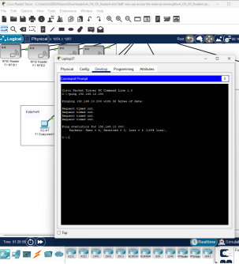

**Test Target:** Student devices → Staff Printer (Security Validation)

**Technical Explanation:** "The Student device (VLAN 20) attempts to communicate with the F1 Printer (VLAN 10) at IP address 192.168.10.200. The Failure result confirms that the STUDENT_ACCESS ACL applied to the Core Router's G0/0/1.20 sub-interface effectively blocks all non-permitted internal traffic, upholding the requirement to isolate the student network from staff resources."

**4.2 Critical Troubleshooting Logs**

Our team encountered the following issues during network configuration and server validation:

**Issue Description:**

Intermittent DHCP allocation failure: Client devices occasionally experience connection delays or failures during the initial DHCP address negotiation process.

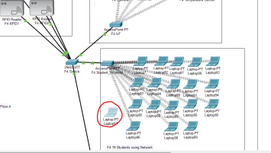

**Root Cause :**

This is typically due to sequencing/timing conflicts between the client device and the DHCP server/relay agent, or failures in initial signaling communication, necessitating a forced restart.

**Resolution Steps:**

Perform a power cycle on the client device to force a restart of the DHCP request process, thereby obtaining a valid IP address upon completion.

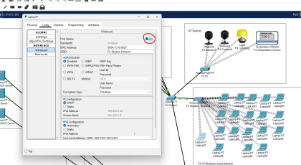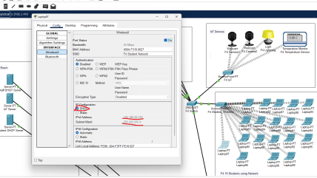

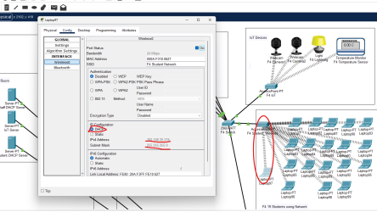

# 5.0 Conclusion

This report will adequately cover the design and detailed setup of a strong and secure network infrastructure of the Smart Library System. It fills in how to get easy network access for different user types—Staff, Students, and IoT devices—from different floors. The network design uses a Hierarchical Logical Design that allows scaling up and makes it easier for administration.

**Network Segmentation and Management:** Four separate VLANs were set up as Staff (VLAN 10), Student (VLAN 20), IoT Devices (VLAN 30), and Library Service (VLAN 40). This brought in easy management, isolation, and security. Key services such as DHCP for dynamic addressing and NAT Overload to allow secure access from the outside were successfully implemented on the Core Router.

**Security Enforcement (ACLs):** Access Control Lists (ACLs) were majorly implemented at the Core Router for the strict enforcement of the security policy. The STUDENT_ACCESS ACL explicitly allows Student devices (VLAN 20) access to only the external services they require access to, i.e., Library Server and Payment Gateway. This was verified in the results as a working security measure.

**Wired and Wireless Reliability:** The physical setup managed to get full Wi-Fi coverage and made sure that important things like Kiosks, E-payment terminals, and servers use steady wired connections. All connection checks, including for Staff PCs, Kiosks, E-payment Terminals, and IoT devices to their right targets worked well. Most importantly, the last check showed that the security rules work right because it proved that Student devices are stopped from getting into inside Staff resources.

The overall network solution provides a secure, reliable, and well-managed platform that meets all functional and security criteria for the modern Smart Library System.

# References

CertBros. (2021, August 24). Cisco Packet Tracer | Everything You need to know [Video]. YouTube. <https://www.youtube.com/watch?v=qZB_biPOBwA>

Cisco. (2023). Hierarchical Network Design Overview. Cisco Networking Academy. <https://www.ciscopress.com/articles/article.asp?p=2202410&seqNum=4>

DigiDev. (2021, December 7). Simulate IoT #13 || cisco packet tracer [Video]. YouTube. <https://www.youtube.com/watch?v=sqU4jx9R5xw>

Lammle, T. (2016). CCNA Routing and Switching Complete Study Guide. Sybex. [https://books.google.com/books?id=c0JJDQAAQBAJ](https://www.google.com/url?sa=E&source=gmail&q=https://books.google.com/books?id=c0JJDQAAQBAJ)

M, M. (2022, April 17). 2.1.1.5 Packet Tracer - Create a Simple Network Using Packet Tracer. Studocu. <https://www.studocu.com/row/document/university-of-management-and-technology/computer-network/2115-packet-tracer-create-a-simple-network-using-packet-tracer/25740481>

Stallings, W. (2013). Data and Computer Communications (10th ed.). Pearson. <https://www.pearson.com/en-us/subject-catalog/p/data-and-computer-communications/P200000003353/9780137561704>

# Appendix

The IP addresses for each of our servers are listed below：

IP Address of Kiosk & E-payment(Default Gateway 192.168.40.1)

|  |  |
| --- | --- |
| F1 Kioks1 | 192.168.40.10 |
| F1 Kioks2 | 192.168.40.11 |
| F1 Kioks3 | 192.168.40.12 |
| F1 Kioks4 | 192.168.40.13 |
| F1 Epayment1 | 192.168.40.14 |
| F1 Epayment2 | 192.168.40.15 |
| F2 Kioks1 | 192.168.40.16 |
| F2 Kioks2 | 192.168.40.17 |
| F3 Kioks1 | 192.168.40.18 |
| F3 Kioks2 | 192.168.40.19 |
| F3 Epayment1 | 192.168.40.20 |
| F4 Kioks1 | 192.168.40.21 |
| F4 Kioks2 | 192.168.40.22 |

IP Address of the 2 printer

|  |  |
| --- | --- |
| F1 Printer | 192.168.10.200 |
| F3 Printer | 192.168.10.201 |

IoT Device IP Address Mapping

|  |  |
| --- | --- |
| F1 Camera1 | 192.168.30.100 |
| F1 Camera2 | 192.168.30.101 |
| F1 Camera3 | 192.168.30.102 |
| F1 Lightning | 192.168.30.103 |
| F1 Temperature Sensor | 192.168.30.104 |
| F1 RFID1 | 192.168.30.105 |
| F1 RFID2 | 192.168.30.106 |
| F1 RFID3 | 192.168.30.107 |
| F1 RFID4 | 192.168.30.108 |
| F2 Camera1 | 192.168.30.109 |
| F2 Camera2 | 192.168.30.110 |
| F2 Lightning | 192.168.30.111 |
| F2 Temperature Sensor | 192.168.30.112 |
| F2 RFID1 | 192.168.30.113 |
| F2 RFID2 | 192.168.30.114 |
| F3 Camera1 | 192.168.30.115 |
| F3 Camera2 | 192.168.30.116 |
| F3 Camera3 | 192.168.30.117 |
| F3 Lightning | 192.168.30.118 |
| F3 Temperature Sensor | 192.168.30.119 |
| F3 RFID1 | 192.168.30.120 |
| F3 RFID2 | 192.168.30.121 |
| F4 Camera1 | 192.168.30.122 |
| F4 Camera2 | 192.168.30.123 |
| F4 Lightning | 192.168.30.124 |
| F4 Temperature Sensor | 192.168.30.125 |
| F4 RFID1 | 192.168.30.126 |
| F4 RFID2 | 192.168.30.127 |